Prometheus is used for monitoring purpose for k8s , docker or even baremetal .
Grafana is used to visualize that prometheus data like in graphs , maps , GUI.

Just install grafana and prometheus on your ubuntu machine.
By just watching some videos on youtube.

And install acos_exporter by clone repo https://github.com/a10networks/PrometheusExporter

And do
pip install -r requirements.txt
Python3 acos_exporter.py

This will install necessary requirement and also run your exporter . this exporter may be collect data from vthunder and send it to Prometheus , and Prometheus send that data to grafana. Where grafana can do quries Prometheus and show that data in graphs , where these graph can be converted into pdf.

In Exporter there is a file name “config.yml”

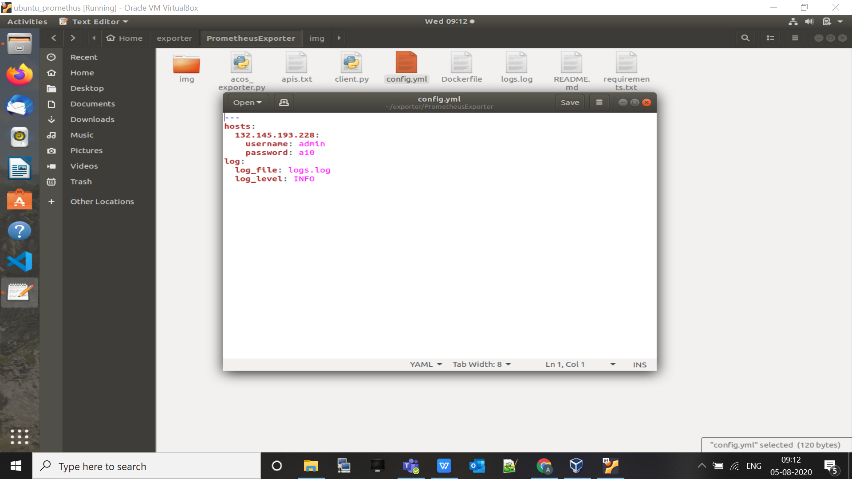

Edit that file as above and run acos_exporter.py as $ python3 acos_exporter.py
- host_ip: ACOS instance IP which is to be monitored
- log_level: Set log_level to DEBUG for debugging purposes. The default log_level is INFO.

By running you can see , port and ip , run that server ip into your browser.

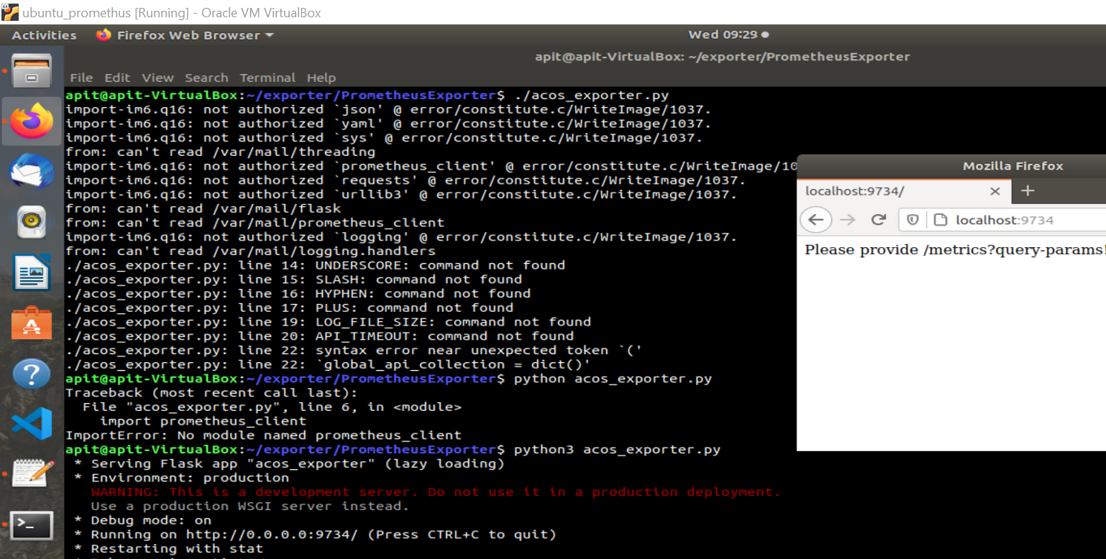

Now run prometheus

Port no - 9090

go to prometheus website download standalone binary . and extract it , you will get edit prometheus.yml file

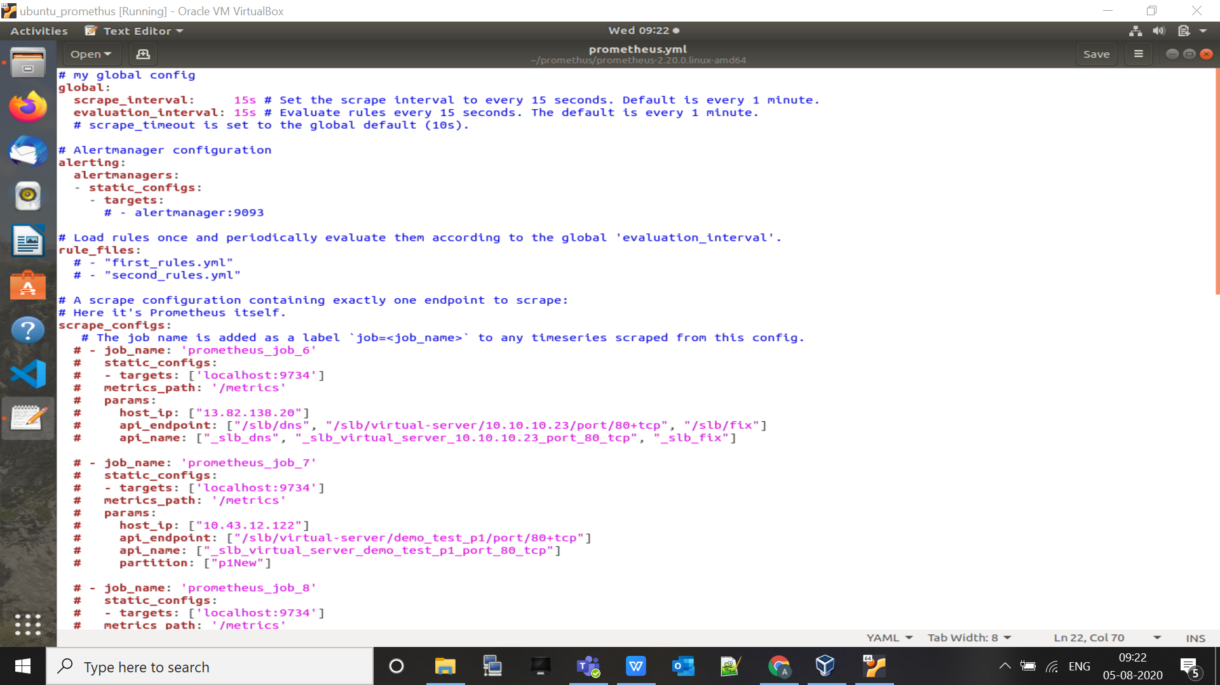

Give certain kind of jobs and , and all the data comes in “/mertics “
Params will be given by other .

Now run ./prometheus and see result in browser

